**Big data Analytics**

# **CS5590BD**

**Lab-4 Assignment**

BY

L V SANDEEP, BATHINA (16174348)

Task1:

Enhance the Android App you developed from Lab 3 by adding the following features

* **Subtask1 : Provide a Save File option once you invoke the HBASE Retrieval operation**

**Steps:**

1. In the Android Application (developed from Lab 3), add one more button with save file as a button name.
2. The event listener for that button will be that the data from the HBase retrieve option will get stored in the file which we provide
3. Run the application on Nexus phone as follows.

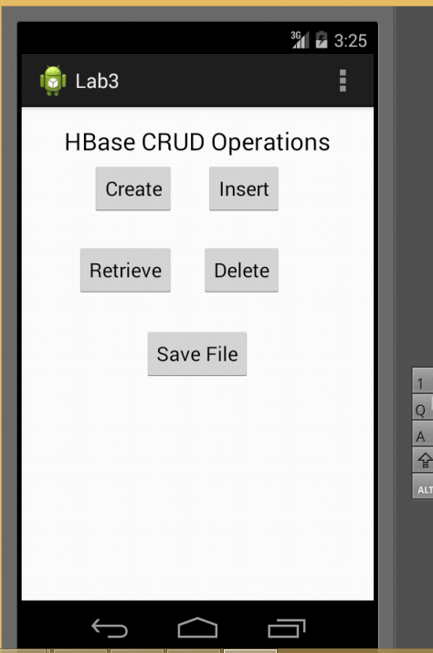

1. The file generated in the system is in the location c://sensor.txt and the file content is as follows.

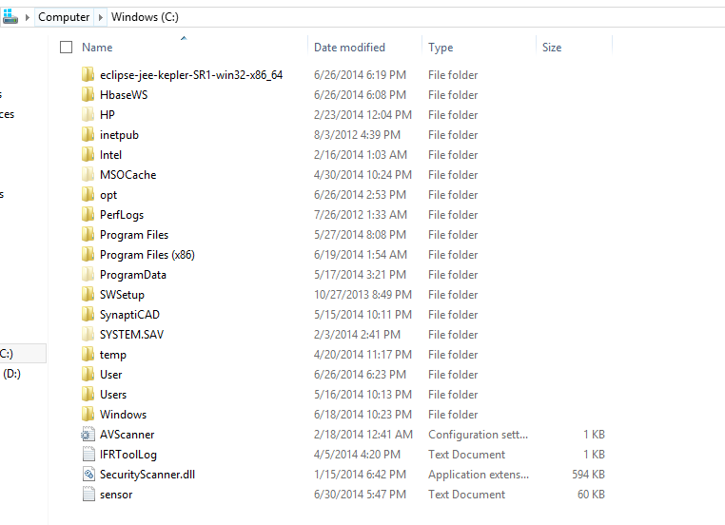

1. Generated file content is:

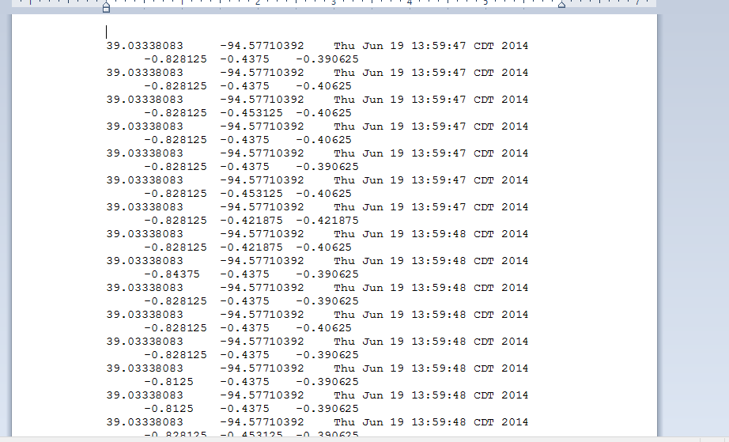

* **Subtask 2: Add an Activity Recognition option to generate a report.**

**Segment and convert to sequence file for Training file:**

**Steps:**

1. Generate the input files (4) from the sensor as follows.

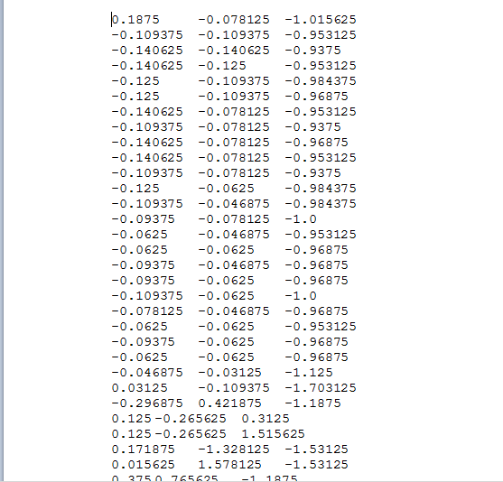

1. We can perform

2) Generated Output sequence file will be:

[http://134.193.136.127:8080/HMMWS/jaxrs/generic/TrainFileOperation/-home-group6-BTPJ.txt/-home-group6-BTPJ.seq](http://134.193.136.127:8080/HMMWS/jaxrs/generic/TrainFileOperation/-home-group6-BTPJ.txt/-home-group6-BTPJ.seq )

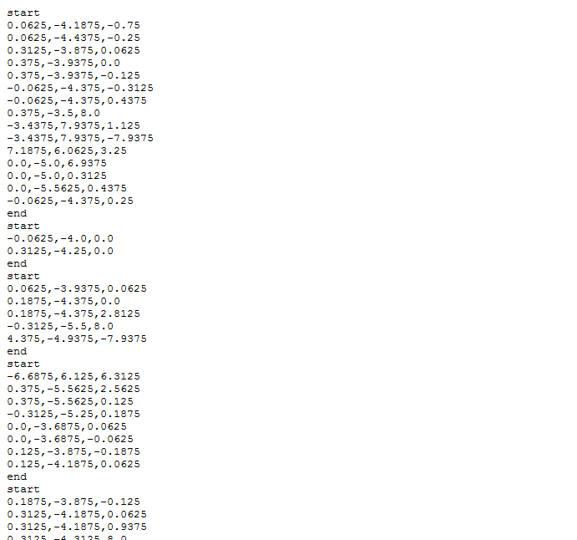

Similarly generate the sequence files for the remaining three text files.

* [http://134.193.136.127:8080/HMMWS/jaxrs/generic/TrainFileOperation/-home-group6-RightToLeftJ.txt/-home-group6-RightToLeft.seq](http://134.193.136.127:8080/HMMWS/jaxrs/generic/TrainFileOperation/-home-group6-RightToLeftJ.txt/-home-group6-RightToLeft.seq%20)
* [http://134.193.136.127:8080/HMMWS/jaxrs/generic/TrainFileOperation/-home-group6-LeftToRightJ.txt/-home-group6-leftrightj.seq](http://134.193.136.127:8080/HMMWS/jaxrs/generic/TrainFileOperation/-home-group6-LeftToRightJ.txt/-home-group6-leftrightj.seq%20)
* [http://134.193.136.127:8080/HMMWS/jaxrs/generic/TrainFileOperation/-home-group6-TestFile-.txt/-home-group6-TestFilej.seq](http://134.193.136.127:8080/HMMWS/jaxrs/generic/TrainFileOperation/-home-group6-TestFile-.txt/-home-group6-TestFilej.seq%20)
* **Subtask 2:** **Training and Testing for Activity Recognition (for three motions as training data)**

**Steps:**

1. The input files for training are the generated sequence files from both the input files of sensor data.
2. Similarly input file for testing will be the combination of all the sequence files.

[http://134.193.136.127:8080/HMMWS/jaxrs/generic/HMMTrainingTest/-home-group6-leftrightj.seq/-home-group6-RightToLeft.seq/-home-group6-BTPJ.seq/-home-group6-TestFilej.seq](http://134.193.136.127:8080/HMMWS/jaxrs/generic/HMMTrainingTest/-home-group6-leftrightj.seq/-home-group6-RightToLeft.seq/-home-group6-BTPJ.seq/-home-group6-TestFilej.seq%20%20)

* **Subtask 3:** **Training and Testing for Activity Recognition (for three motions as training data)**

**Input sequence files for Training:** home/cloudera/BTPJ.seq, RightToLeft.seq, leftrightj.seq

**Testing:** home/cloudera/TestFilej.seq

**Input actions for training:**btp: rtol: ltor

Now run below service using the generated sequence files to identify the motions.

<http://134.193.136.127:8080/HMMWS2/jaxrs/generic/HMMTrainingTest/-home-cloudera-BTPJ.seq:-home-cloudera-RightToLeft.seq:-home-cloudera-leftrightj.seq/btp:rtol:ltor/-home-cloudera-TestFilej.seq>